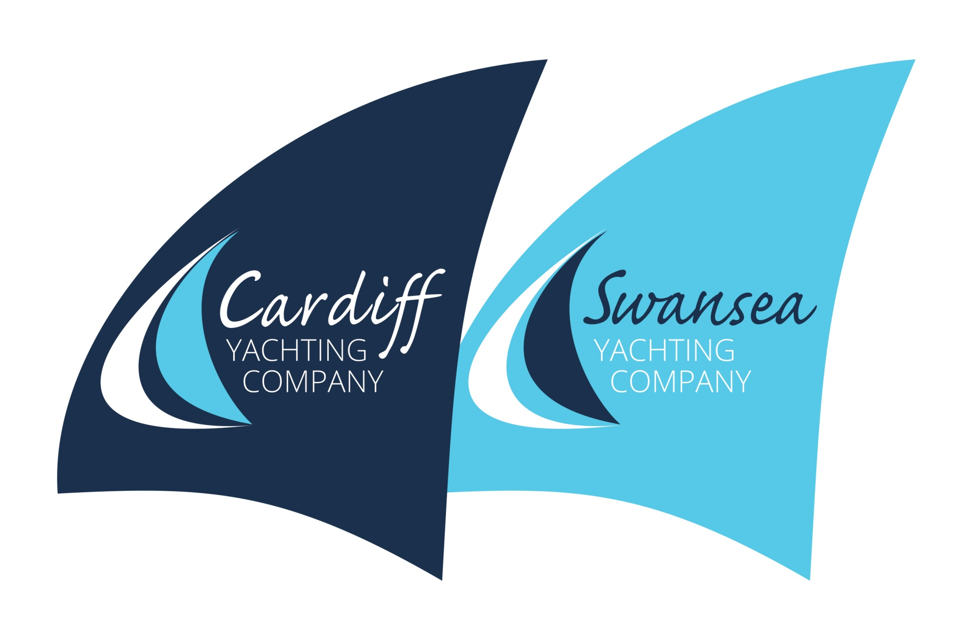

Individual Booking Form

Event/Course |  | Date(s)
Name |  | Address &  Postcode
Email
Mobile | 07
If you are under 18, you must be accompanied by a parent/guardian throughout the event / course and they must complete and sign the Parental/Guardian Agreement Form.
Dietary | No or add?
Medical/Treatments/  Disability | No or add?
Boating Competency,  Swim Ability (25m)? |  | Next of kin  (Relationship)  Mobile No.

- Please take this as booking for the above event.
- I declare that I have mentioned any matters above regarding my fitness to take part in the course. Illness or medical conditions need not preclude the ability to take part in the course, if unsure consult your GP.
- I understand that participation in boating has risks and as part of the crew or student I will undertake orders when practical to do so. I will undertake to keep myself safe at all times including the wearing of a lifejacket, and a safety line (when instructed to do so) when on deck.
- My signature below confirms that I have read and understood and will comply with the Cardiff & Swansea Yachting Company Limited Terms and Conditions provided on the website by way of a pdf copy.
- Cardiff & Swansea Yacht Company strives to provide the very best service to customers at all times. In the event of any shortfall (the weather is beyond our control!), I undertake to make contact with the skipper directly should there be any cause for complaint to allow for any remedial action to be considered as soon as practical.

Signed |  | Dated

.

PARENTAL/GUARDIAN AGREEMENT
(to be completed if the participant is aged under 18)

Name of participant
Name of parent/guardian completing this form
Relationship to participant
Contact number during Event

Supervision
I will be responsible for, and accompany my child throughout the event/course.

OR

I appoint the person named below, who has agreed to act in loco parentis. He/she will be responsible for and accompany my dependant throughout the event.

Name of person appointed
in loco parentis ……………………………………… Mobile number…………………………………

Medical treatment
I or the person who has agreed to act in loco parentis can give permission to the organisers to administer any relevant treatment or medication to the above-named participant when or if necessary or in In an emergency situation accompany the child to hospital.

Use of your child’s image
Cardiff Yachting Company Policy is NOT to take any images of any child nor subsequently publish or post on social media
PARENTAL/GUARDIAN AGREEMENT (if under 18)

I agree that ___________________ may take part in the Event. I confirm that I have read through the above conditions with him/her and that she/he understands and agrees with them. I also confirm that he/she takes part in the Event with my full agreement that that the particulars given above are correct and complete in all respects.

Signed…………………………………………Parent/Guardian……………………….

Date…………..

