Cardiff & Swansea
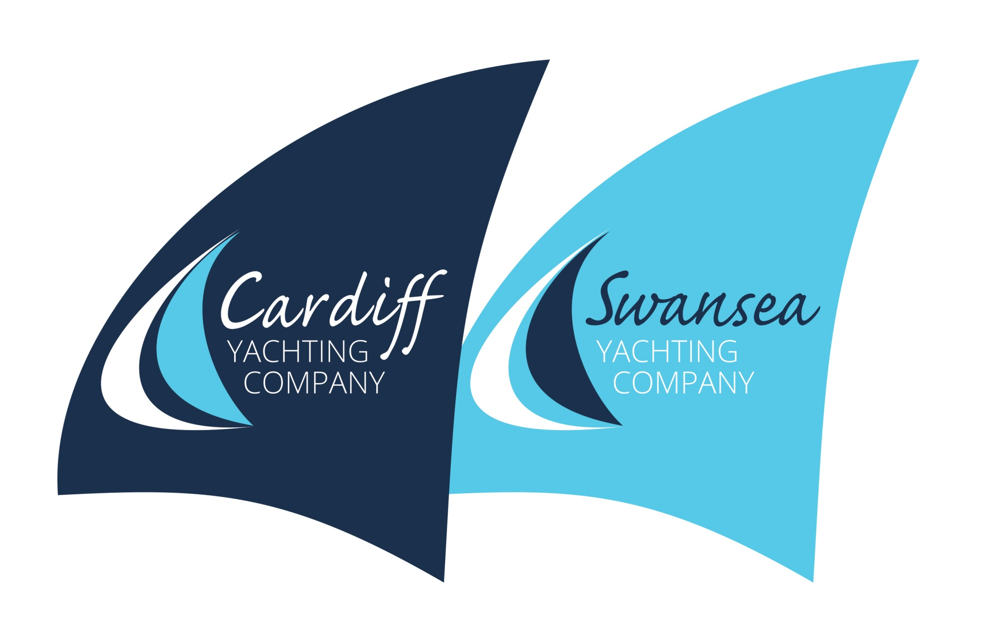
Yachting Company Limited

Company Terms and Conditions

The following terms and conditions apply to all of the services that Cardiff & Swansea Yacht Company Limited (CSYCo) provides to customers.

BOOKING
- The posting of a signed application to CSYCo or a telephone booking or an email booking or an online booking, or a booking made in person followed by a verbal acceptance, or an acceptance letter or email sent by CSYCo forms the basis of a contract.
- Bookings will only be accepted when accompanied by the appropriate Booking Deposit or Fees paid in Full.
- Booking Deposits are non-refundable.
- Full Fees must be made (and cleared with our bank) by the date outlined on the invoice. If full payment is not made by this date then CSYCo reserves the right to re-sell your place and you will forfeit your booking deposit.
- Services booked within two weeks of the event must pay the full fee at the time of booking.

PAYMENT OF BOOKING DEPOSIT & FEES
RYA Powerboat Courses - Deposit is 20% of fees (minimum £100) Balance to be paid in full 4 weeks before the course start date.
Skippered Charter, Team Building and Group Days - Deposit is 20% of fees (minimum £100) Balance to be paid in full 4 weeks before the charter/event date.
Tasters, Skills Development & Day Cruises - Full payment to be made at the time of booking.
Classroom Courses - Full course fee payable at time of booking
Projects including Own Yacht Tuition - Non-refundable 25% of estimated fees on acceptance of contract and full payment within 7 days of invoice.
Sail Yacht Delivery
Separate Terms and Conditions are applicable for this type of service.

BACS TRANSFER  Swansea Yacht Company  Sort Code: 09-01-29  A/C number: 10734315  Please Quote Invoice No. | PayPal INVOICE  ON REQUEST - Swansea Yacht Company will email you an invoice with a PayPal button. Payment can be made using your PayPal account or a debit/credit card.
CANCELLATION BY CUSTOMER
Cancellations made before the four weeks of an event will only forfeit the booking deposit, cancellations made after this date will be liable for their full fees in all cases.
CANCELLATION BY CARDIFF & SWANSEA YACHT COMPANY LIMITED & CHANGES TO PROGRAMME
CSYCo reserves the right to cancel or postpone any booking at any time.
The weather forecast will be a factor that affects day to day to operations. In general terms winds forecast in excess of Force 6, air temperature at mid-afternoon of less than 5°C and associated with winds greater than Force 5 will cause the event to be cancelled. CSYCo will undertake to inform you of this decision and confirmation of such will be made at least 36 hours from the start of the event. Efforts will be made for an alternative date to be scheduled as soon as practical. Should an alternative not be acceptable to both parties then the deposit or any monies paid will be returned in full minus a 10% administration fee. We will not be liable for any other costs that you may incur as a result of this cancellation..
We recommend you consider discussing your event, race or charter with an insurance company so that you are covered for both your fees and any other costs (travel, accommodation etc), if the course is cancelled.
CSYCo reserves the right to make changes to the advertised craft and programme.
SAFETY & MEDICAL
- By enrolling on any of our courses/events you accept that there is a risk involved with water sports, offshore sailing and the other activities we run.
- On matters of safety, the decision of your Skipper/instructor is final.
- You must be in good physical health at the start of your course event, charter or race (if in doubt, consult your GP).
- It is your responsibility to decide if you are fit and healthy enough to start or continue any activity.
- The decision as to whether to participate in any of our activities lies with the participant.
- You must inform your instructor or skipper if you are taking any form of medication. For live aboard courses please bring double your usual dose. This means that you can carry your usual dose and your skipper can keep a reserve for emergencies.
- You must be able to swim a minimum of 25m for all practical courses
- Next of Kin details are required for events or courses over 24 hours duration.
CERTIFICATION
CSYCo will provide all the necessary coaching, but as with all training courses and exams, we cannot guarantee you pass. For externally moderated exams, an appeals process is in place at the RYA.
GENERAL
- Guests / Students agree to the craft and accommodation allocated to them.
- CSYCo reserves the right to terminate your course or event at any time if your behaviour is unacceptable. In this instance, we have no obligation to pay for any return travel costs or to refund any monies paid to us.
- All correspondence and briefings are given in the English Language. Certificate of Competence Candidates will be required to deliver briefings in English as part of their course.
- CSYCo and it’s Skippers may retire from or abandon any sailing/boating activity at any time, if they consider it the appropriate course of action on the grounds of safety.
- CSYCo is not responsible for any loss or damage to your personal possessions while you are with us.
- CSYCo reserves the right to vary these terms.
- All students must have foul weather gear/waterproofs at all times of year whether provided by themselves or us.
MINIMUM AGE
A parent or legal guardian must sign a consent form for all under eighteens on Practical courses, AND the parent, legal guardian or responsible adult must accompany anyone under the age of eighteen on any of our events.
WHAT’S INCLUDED
Waterproofs are provided free of charge.
No meals/beverages will be provided on Powerboat courses or event bookings.
Beverages on board X Beat II are included in the fees and a light lunch if the event is for the day. If the event extends beyond a day breakfast is provided on board. Evening meals aboard will not be provided unless it is impractical to go ashore. With the exception of Skippered Charter Events, fuel, gas and marina fees are included in the event fees.
PHOTOGRAPHY
Adults - From time to time our staff and agents will take images or video footage of our events. These photographs and moving images can be used by us for advertisements, marketing, leaflets, education, training and publicity purposes. If you would prefer that we did not photograph or film you, please let us know by email before the course starts or tell your Instructor at the welcome briefing and we will ensure you are not filmed or photographed by us.
Children - CSYCo staff members will not take any photographs of any child whilst on board nor use such images on any company promotion or social media.

YOUR PERSONAL DATA MANGAGEMENT
Cardiff & Swansea Yacht Company Policy
We take our responsibility to managing your personal data seriously and will comply with legislation and best practice. The information that you supply on a company booking form, (downloaded or via the website) will only be kept for internal administrative purposes. The accuracy of personal data held will depend on the person who made it. Data will be stored only for this purpose, and deleted as soon as is practical as outlined below.
Any payments for events or courses are made through bank transfer or PayPal – consequently no data concerning YOUR payment details are downloaded or stored on CSYCo database.
Your Event or Course, Name, Address, Date of Birth, Medical Information, Next of Kin, mobile and email address are recorded and stored for efficient and effective administration of the company in running the event or course (or series). Your data will be used in direct communication concerning the event or course you are booked on. It will not be seen or shared with third parties. You will only receive marketing emails from CSYCo (max. 4 a year) if you specifically request it. If you do not it will be assumed that you do not wish to be contacted.
After a period of 6 months after your last contact with the company your data will be deleted other than your name, and details about your event/ course which you booked. This is kept for company records and HMRC inspection showing that the business has run in compliance of the relevant legislation. Following a period of 6 years, this data will also be deleted.

RYA Interactive Policy
To enable access to your online course we need to share some of your personal data with the RYA via your user profile in www.ryainteractive.org. This learning management website is hosted and maintained by a third party called Learning Pool, who will not use your personal information for any reason other than enabling your course. Your name and email address will be entered on www.ryainteractive.org in order to create your user account. On your first access to the site, you will be asked to enter your address and date of birth. You will have access to the site for one year in order to complete your online course. During this period, your personal information will be held on the website by Learning Pool and be available to this training centre and the RYA for the purpose of managing your course.
Instructional support will be provided by this training centre for a period of 12 months from the date of your course booking. On completion of your course, your name, email, date of birth and address will be transferred to the RYA's central database for the purpose of recording details of the course and any certification you gain as a result of it. This information allows the RYA to record your certification, to update any records they may already hold about you or your qualifications and to verify your certificate if required. After one year from the date of your enrolment on the course, your user account will be removed from www.ryainteractive.org.

OWN BOAT TUITION
For own boat tuition and boat delivery you must ensure your craft is fully insured and you have informed your insurance company that an instructor will be on board. During Own Boat Tuition the owner will remain the skipper. The Instructor’s decision to stay ashore or head for a safe port is final when involving matters of safety. The owner must provide meals for the instructor as well as cover all mooring, fuel and general boat expenses. The owner is also expected to pay the instructor’s return travel expenses beyond 15 miles of Church Village or Cardiff to your yacht.
CSYCo reserves the right to cancel an own boat tuition course at any time without refund if they, their staff or agents consider the boat to be unfit or un-seaworthy. Owners must ensure that their craft is equipped with all the appropriate equipment for safe navigation and passage.

COMPLAINTS
In the unlikely event that you are unhappy with any part of your event or dealings with us, we do need to know. In the first instance, tell your instructor or any member of staff, as many problems can be resolved while you are on the course.
If they cannot resolve the problem then you are advised to write to The Director at the company address – 4 Coed Y Broch, Church Village, Pontypridd CF38 1BQ within 7 days of your course, race or charter ending.
Your letter will need to explain what the problem was, who you made aware of the problem, what was done or not done, and what you would like done now.
Please mark this letter "private and confidential".
The Director will normally respond to you within fourteen days. If you are not satisfied with our response then you may of course contact the RYA, MCA or any other body you feel is appropriate to your complaint.

